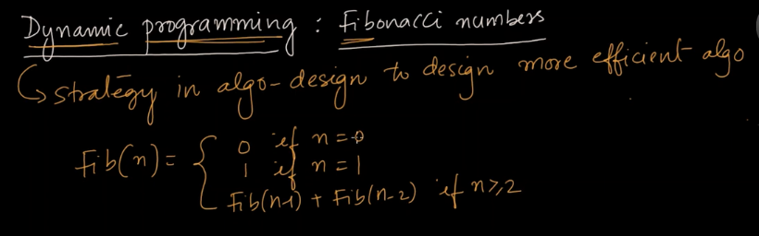

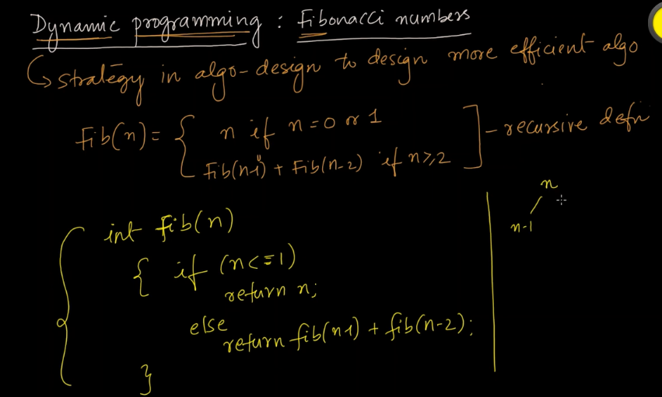

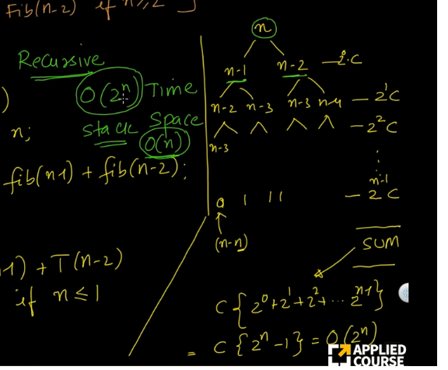

time complexity is very very high.

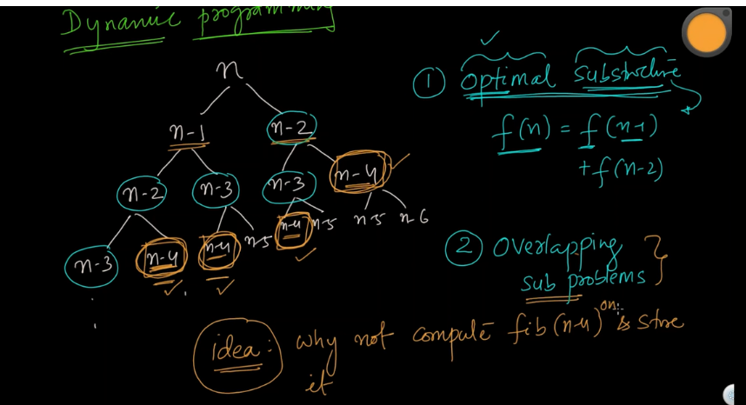

It has optimal substructure where the problem will be divided by the subproblem with the same function with lesser value.

The larger problem can be solved by the subproblems of the large problem.

Overlapping subproblem means we will calcualate the values of n-4,n-5,n-3 and store it and use it later.

Dynamic Programming should satisfy the above two properties.

There are two types of Dynamic Programming.

1)Top Down

2)Bottom Up

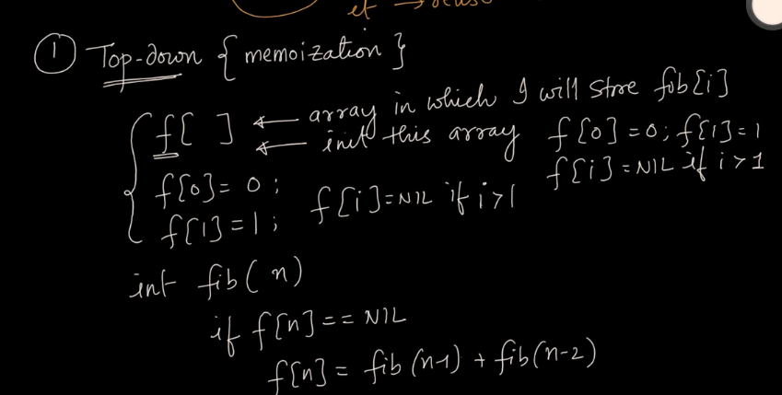

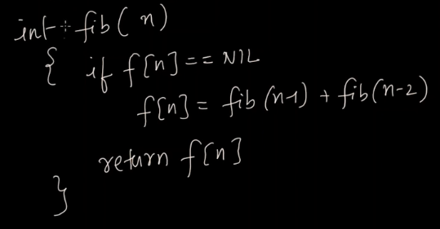

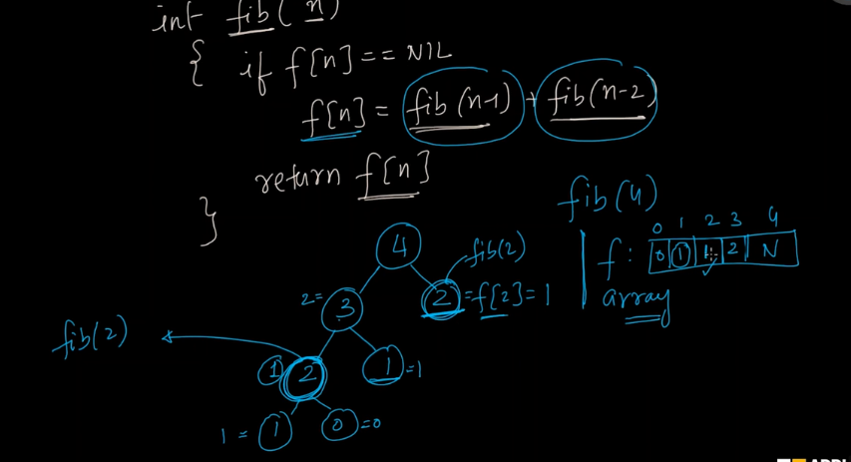

I will store the values in the array and use it when required in the left tree. We dont need to calcualate it everytime.

Memoziation:- Means stroing the intermediate results in an array and use it whenever required.

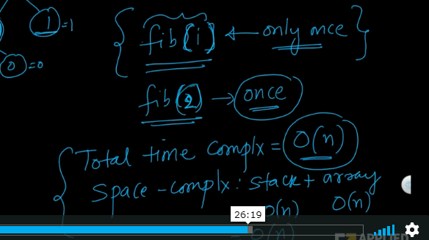

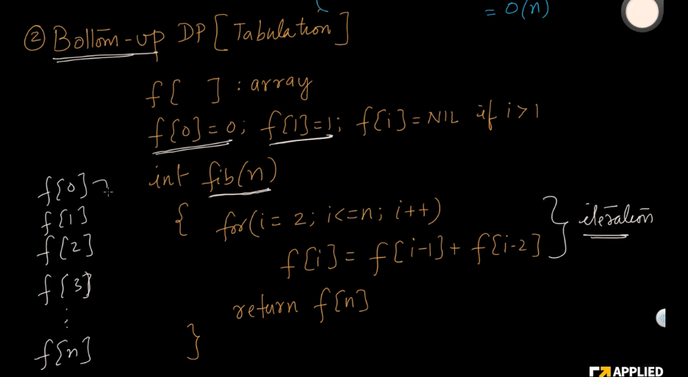

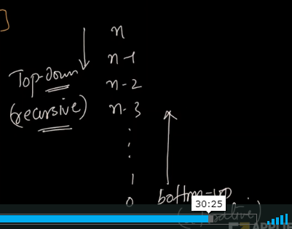

Bottom up is iterative.

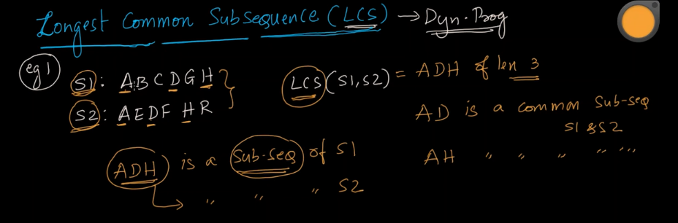

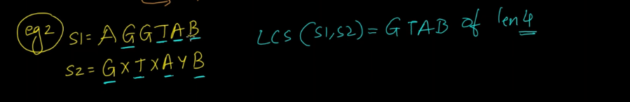

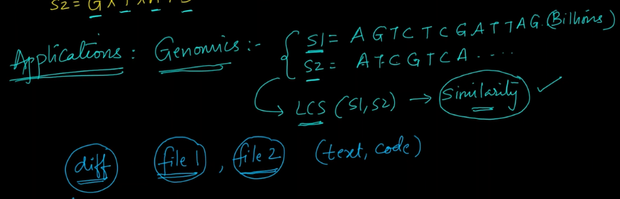

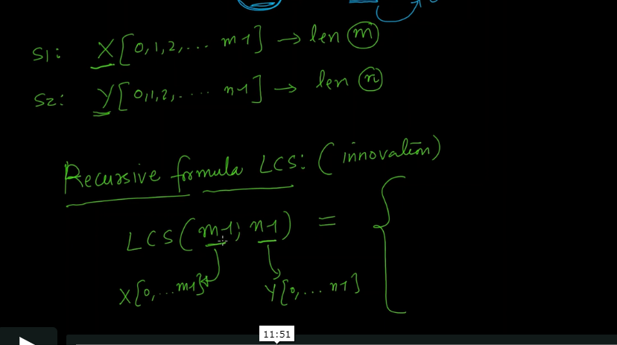

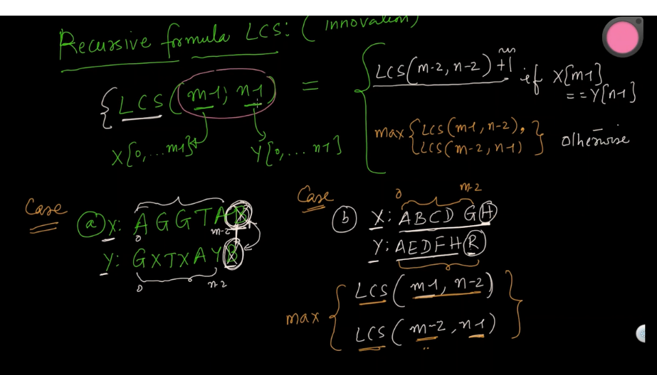

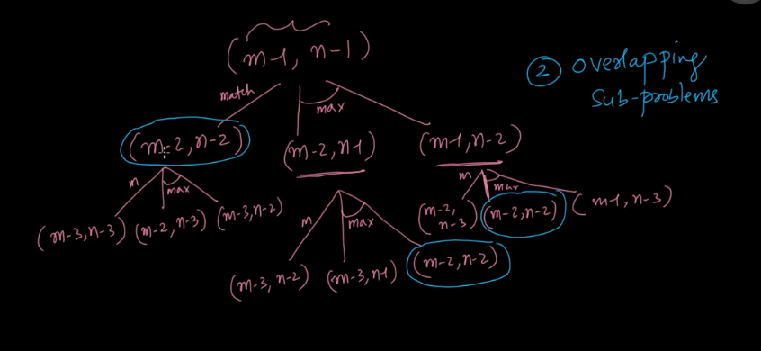

the recursive tree is shown as above.

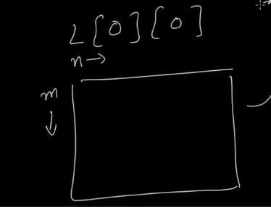

So i can store the results in two dimensional array where m=first string and n=second substring.

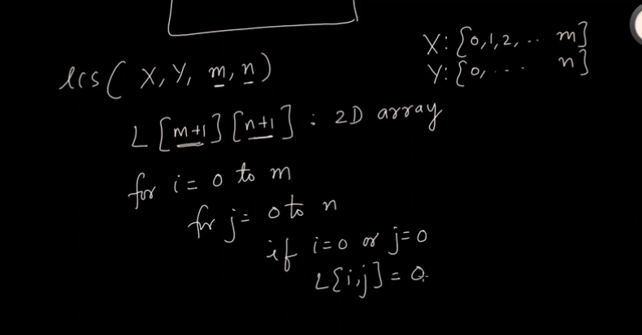

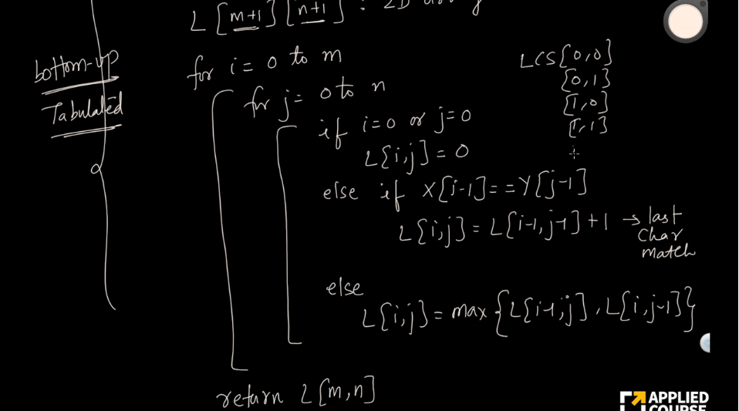

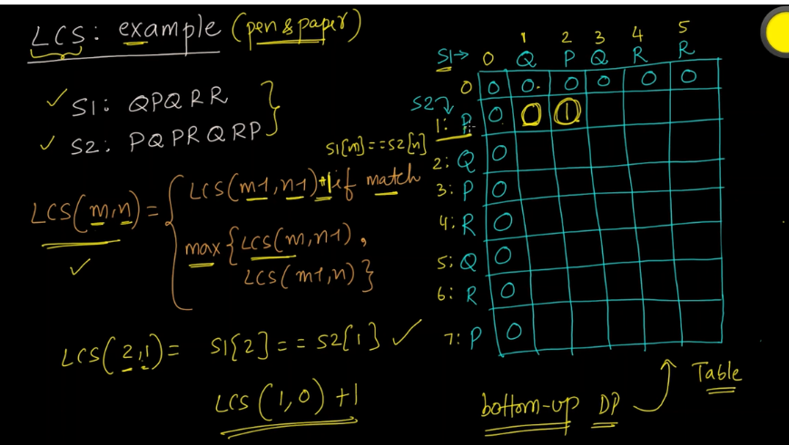

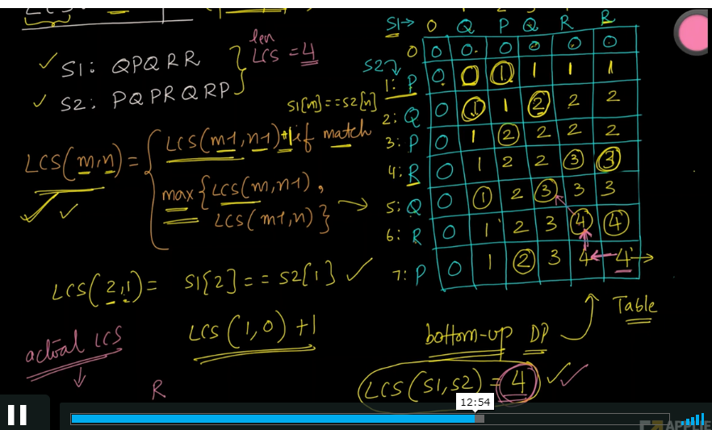

def lcs(X , Y):

    # find the length of the strings

    m = len(X)

    n = len(Y)

    # declaring the array for storing the dp values

    L = [[None]*(n+1) for i in xrange(m+1)]

    """Following steps build L[m+1][n+1] in bottom up fashion

    Note: L[i][j] contains length of LCS of X[0..i-1]

    and Y[0..j-1]"""

    for i in range(m+1):

        for j in range(n+1):

            if i == 0 or j == 0 :

                L[i][j] = 0

            elif X[i-1] == Y[j-1]:

                L[i][j] = L[i-1][j-1]+1

            else:

                L[i][j] = max(L[i-1][j] , L[i][j-1])

    # L[m][n] contains the length of LCS of X[0..n-1] & Y[0..m-1]

    return L[m][n]

# Driver program to test the above function

X = "AGGTAB"

Y = "GXTXAYB"

print "Length of LCS is ", lcs(X, Y)

s

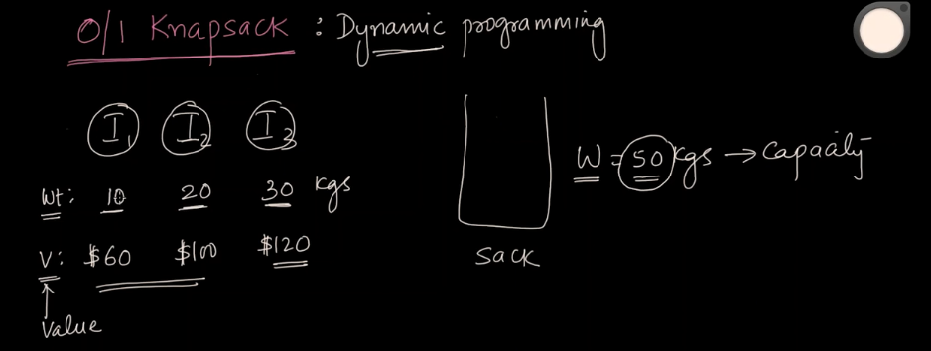

Given weights and values of n items, put these items in a knapsack of capacity W to get the maximum total value in the knapsack. In other words, given two integer arrays val[0..n-1] and wt[0..n-1] which represent values and weights associated with n items respectively. Also given an integer W which represents knapsack capacity, find out the maximum value subset of val[] such that sum of the weights of this subset is smaller than or equal to W. You cannot break an item, either pick the complete item or don’t pick it (0-1 property).s

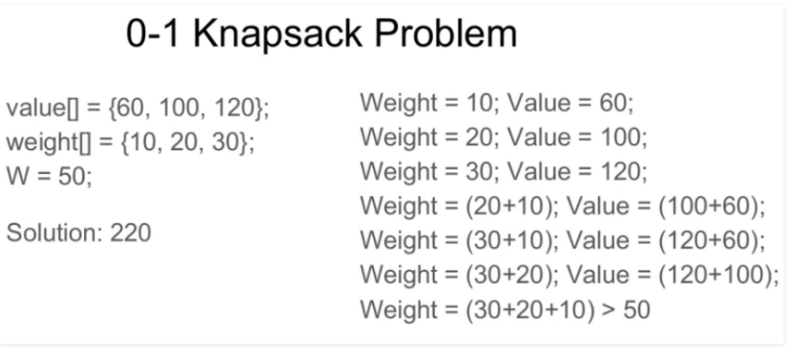s

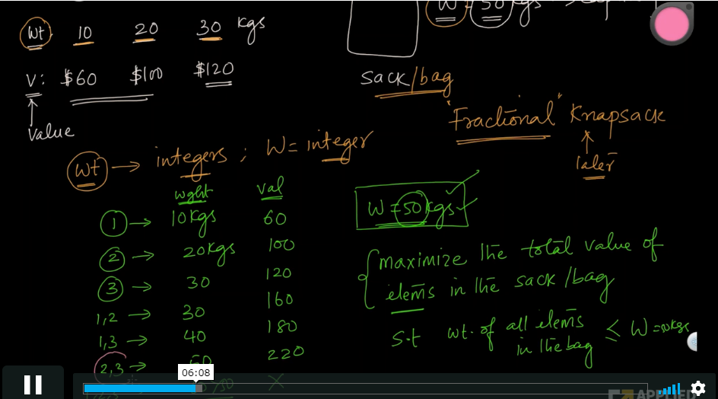

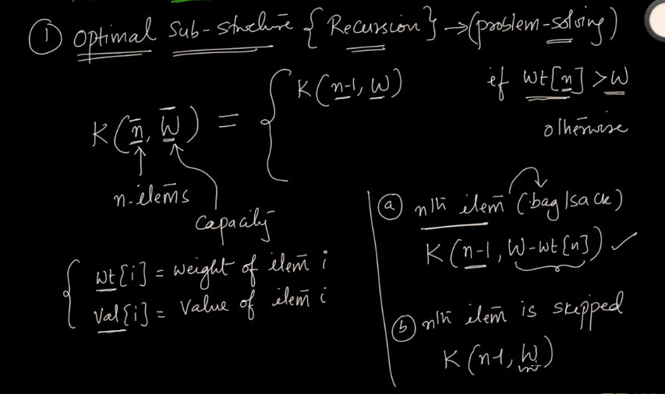

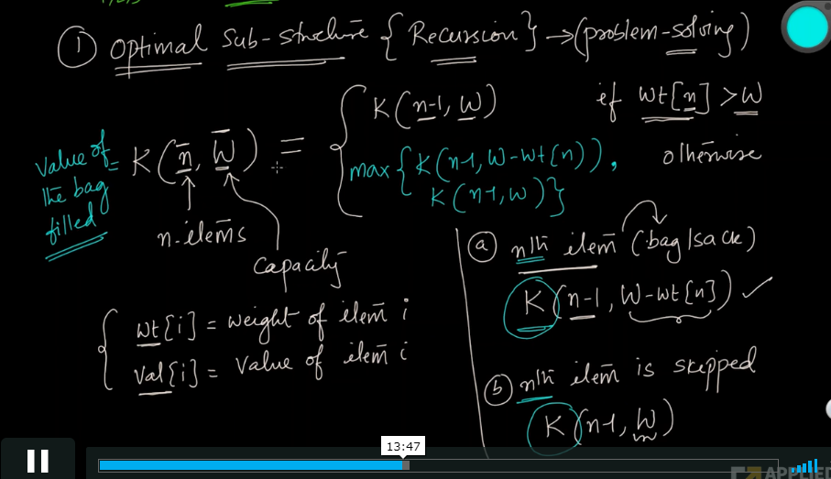

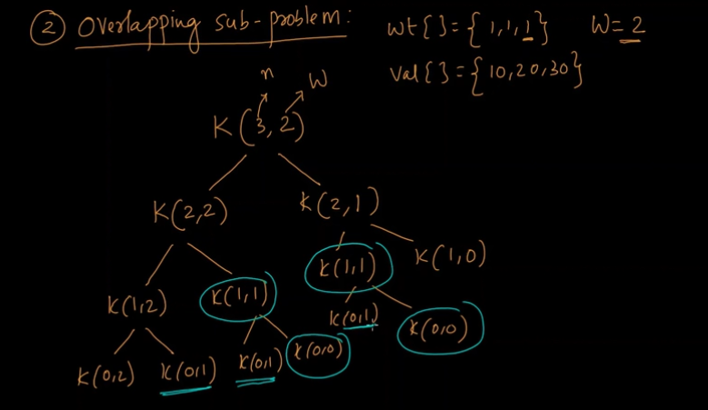

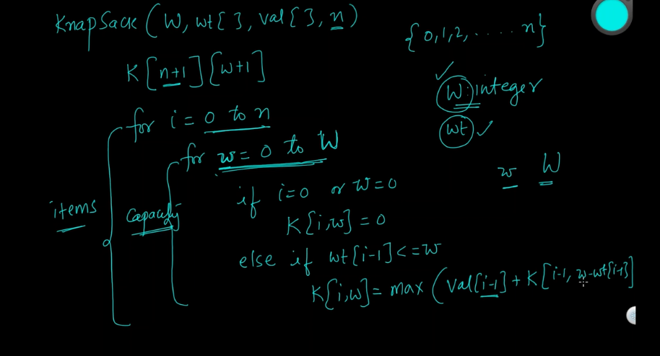

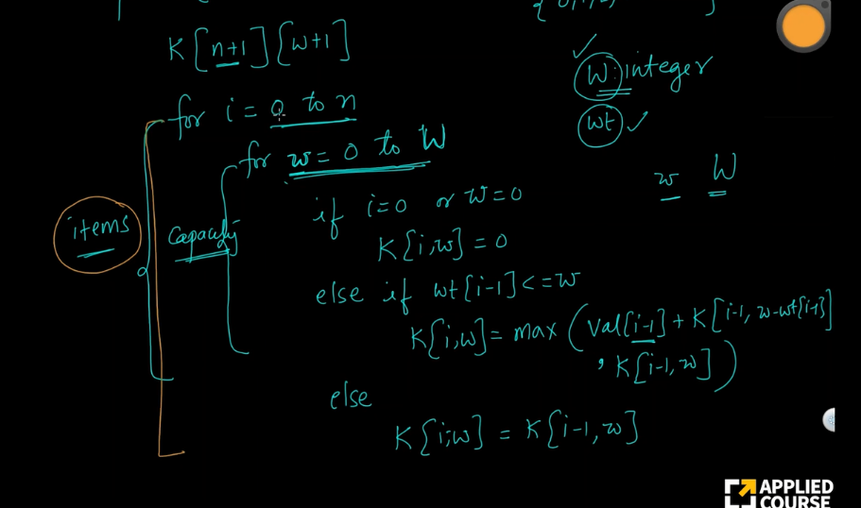

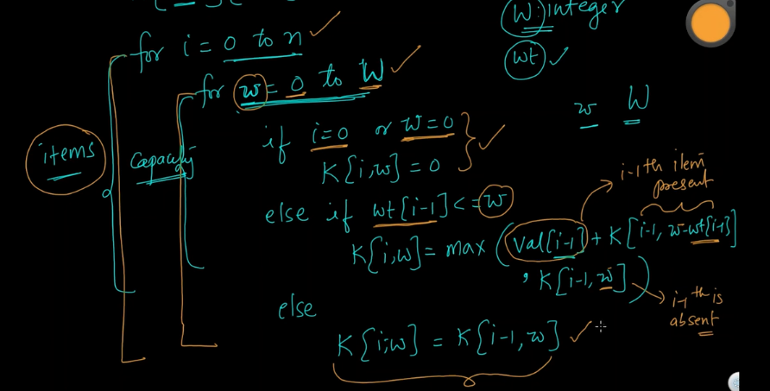

sdef knapSack(W, wt, val, n):

    K = [[0 for x in range(W + 1)] for x in range(n + 1)]

    # Build table K[][] in bottom up manner

    for i in range(n + 1):

        for w in range(W + 1):

            if i == 0 or w == 0:

                K[i][w] = 0

            elif wt[i-1] <= w:

                K[i][w] = max(val[i-1]

                          + K[i-1][w-wt[i-1]],

                              K[i-1][w])

            else:

                K[i][w] = K[i-1][w]

    return K[n][W]

ss

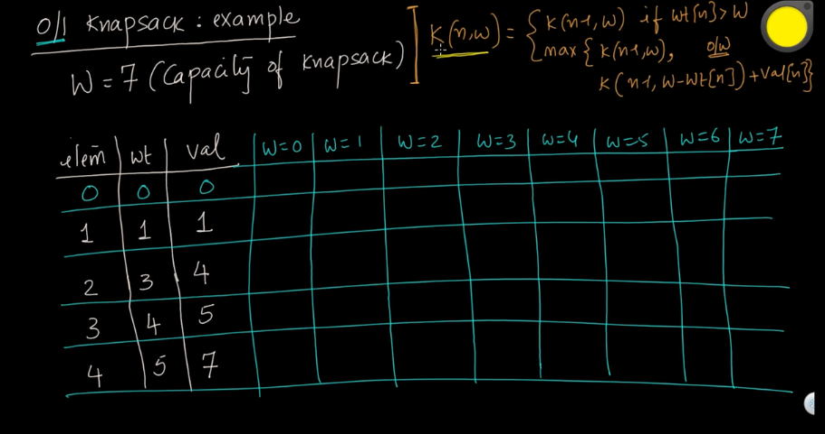

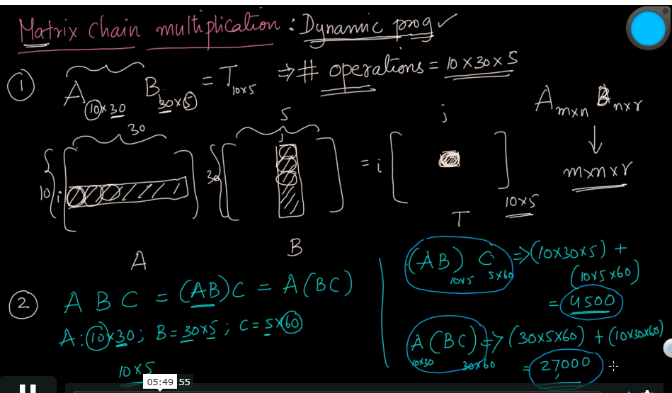

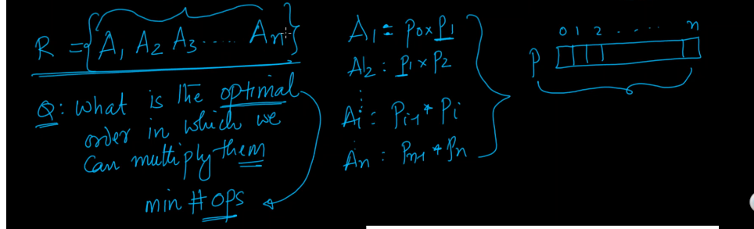

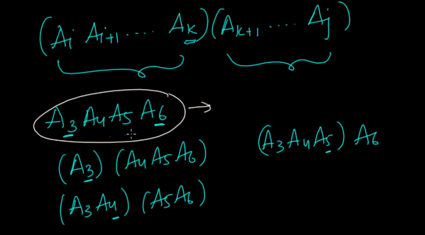

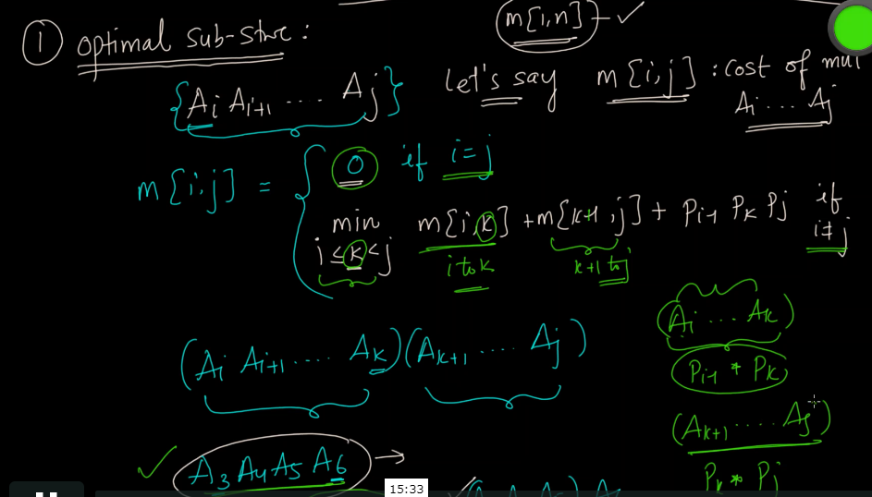

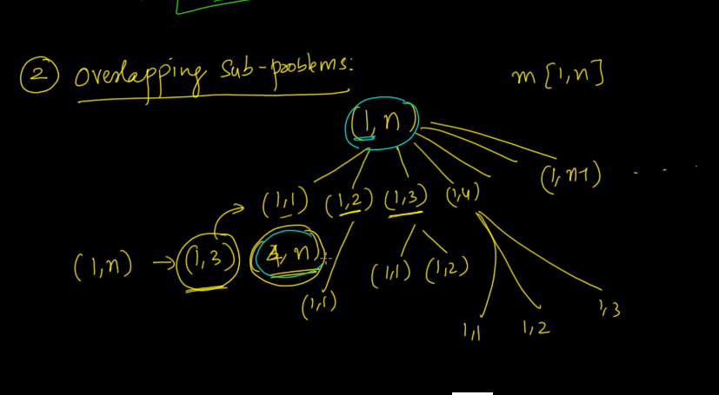

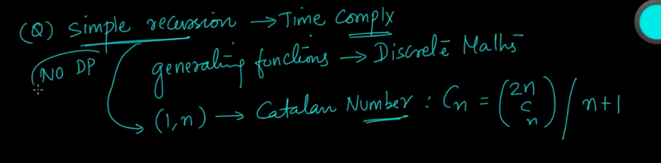

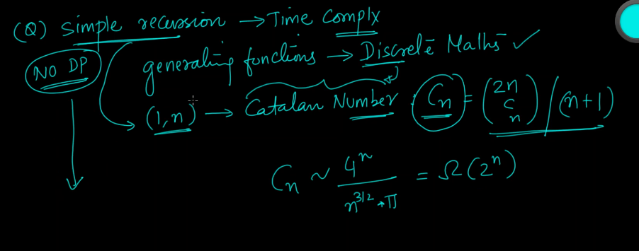

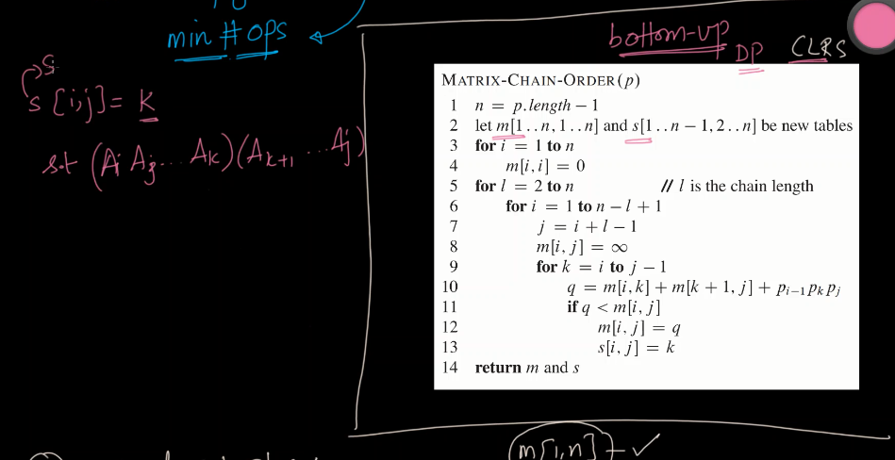

In the matrix, S[i,j], we are storing the optimal value of K where i am splitting the multiplication.

*Given an array p[] which represents the chain of matrices such that the ith matrix Ai is of dimension p[i-1] x p[i]. We need to write a function MatrixChainOrder() that should return the minimum number of multiplications needed to multiply the chain.*

**Input: p[] = {40, 20, 30, 10, 30}**

**Output: 26000**

There are 4 matrices of dimensions 40x20, 20x30, 30x10 and 10x30.

Let the input 4 matrices be A, B, C and D. The minimum number of

multiplications are obtained by putting parenthesis in following way

(A(BC))D --> 20*30*10 + 40*20*10 + 40*10*30

**Input: p[] = {10, 20, 30, 40, 30}**

**Output: 30000**

There are 4 matrices of dimensions 10x20, 20x30, 30x40 and 40x30.

Let the input 4 matrices be A, B, C and D. The minimum number of

multiplications are obtained by putting parenthesis in following way

((AB)C)D --> 10*20*30 + 10*30*40 + 10*40*30

**Input: p[] = {10, 20, 30}**

**Output: 6000**

There are only two matrices of dimensions 10x20 and 20x30. So there

is only one way to multiply the matrices, cost of which is 10*20*30

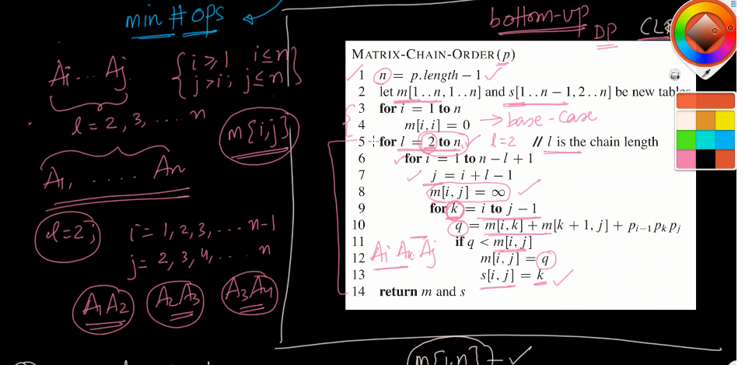

Here l means we are splitting the matrix with a group of 2.

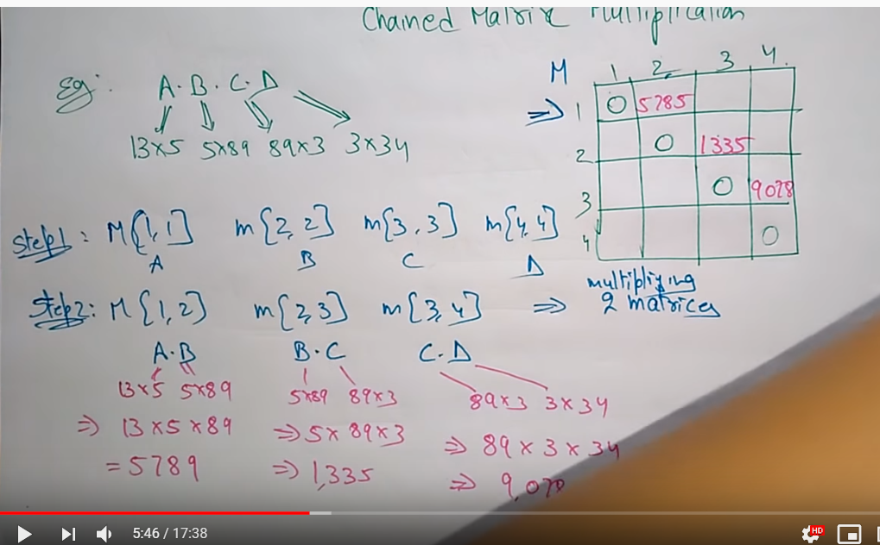

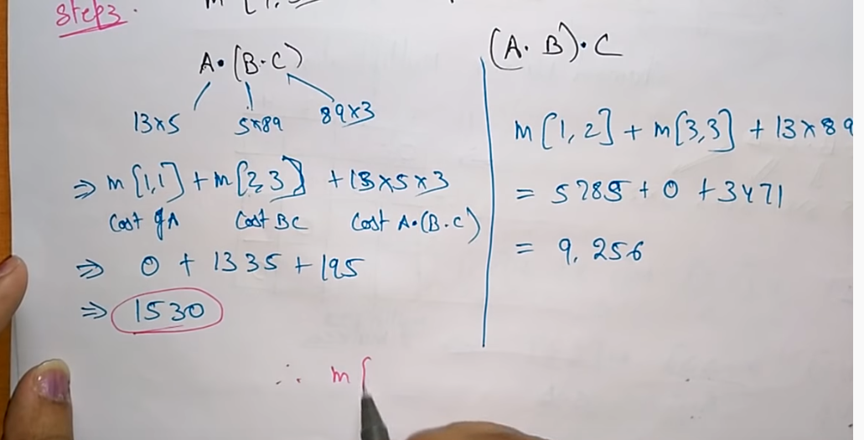

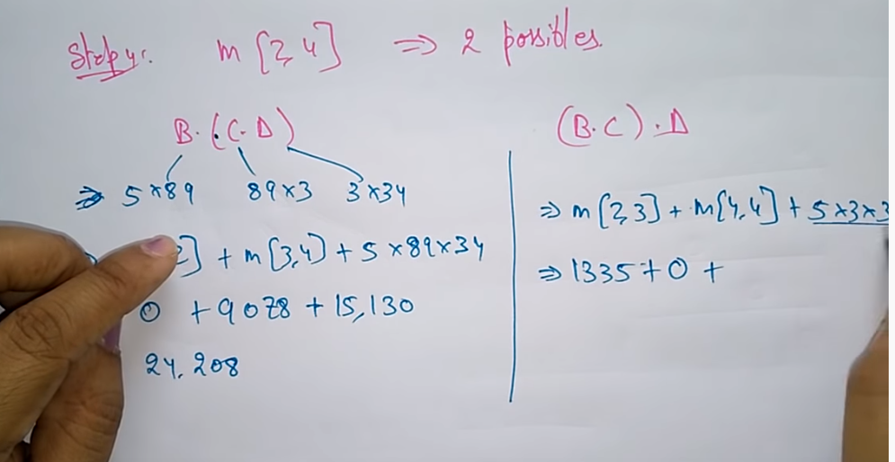

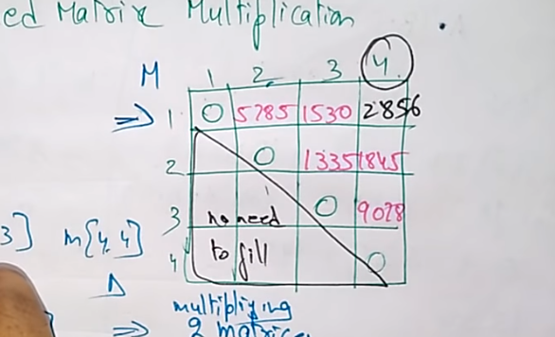

|  |
| --- |
| import sys    # Matrix Ai has dimension p[i-1] x p[i] for i = 1..n      def MatrixChainOrder(p, n):      # For simplicity of the program,      # one extra row and one      # extra column are allocated in m[][].      # 0th row and 0th      # column of m[][] are not used      m = [[0 for x in range(n)] for x in range(n)]        # m[i, j] = Minimum number of scalar      # multiplications needed      # to compute the matrix A[i]A[i + 1]...A[j] =      # A[i..j] where      # dimension of A[i] is p[i-1] x p[i]        # cost is zero when multiplying one matrix.      for i in range(1, n):          m[i][i] = 0        # L is chain length.      for L in range(2, n):          for i in range(1, n-L + 1):              j = i + L-1              m[i][j] = sys.maxint              for k in range(i, j):                    # q = cost / scalar multiplications                  q = m[i][k] + m[k + 1][j] + p[i-1]*p[k]*p[j]                  if q < m[i][j]:                      m[i][j] = q        return m[1][n-1]      # Driver code  arr = [1, 2, 3, 4]  size = len(arr)    print("Minimum number of multiplications is " +        str(MatrixChainOrder(arr, size)))  # This Code is contributed by Bhavya Jain |

**Output**

Minimum number of multiplications is 18

sss

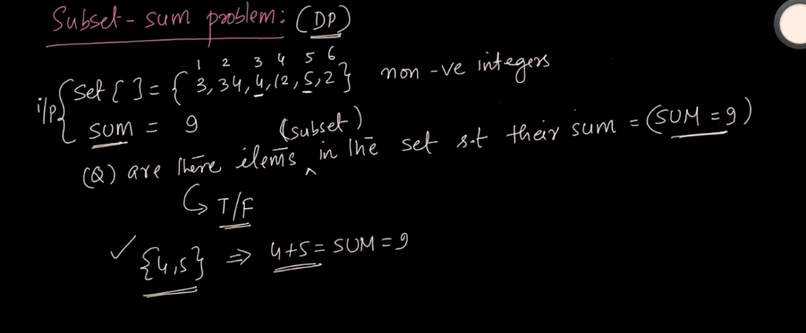

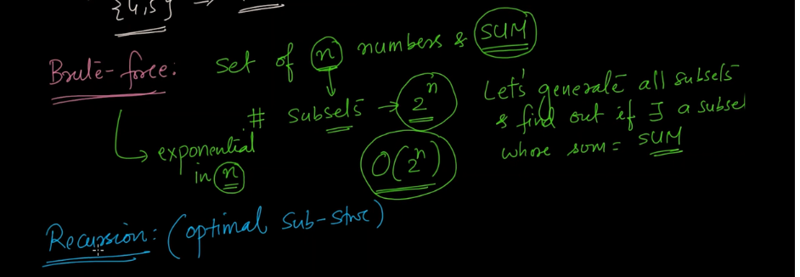

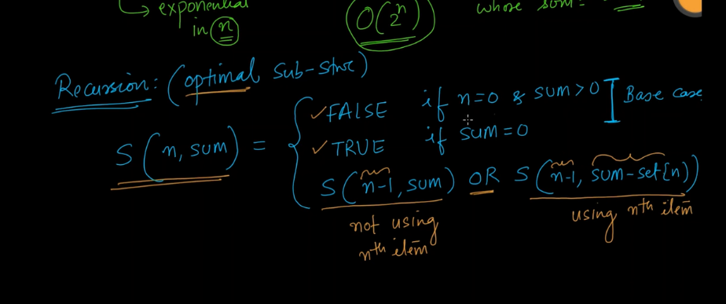

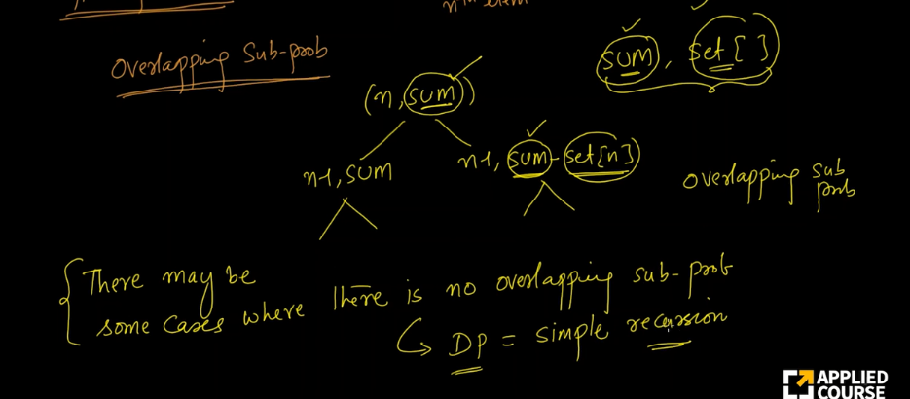

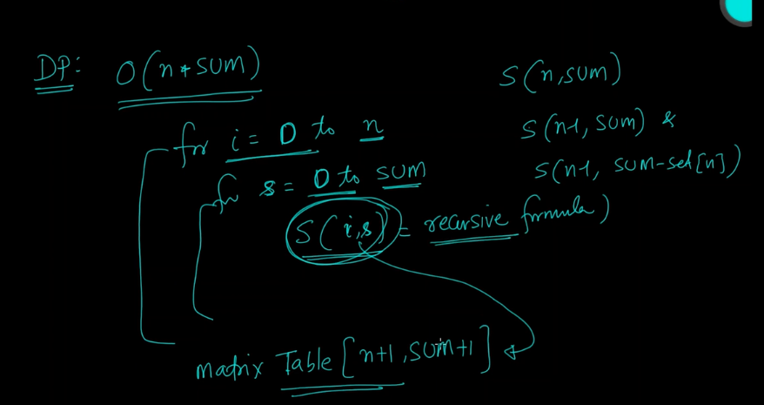

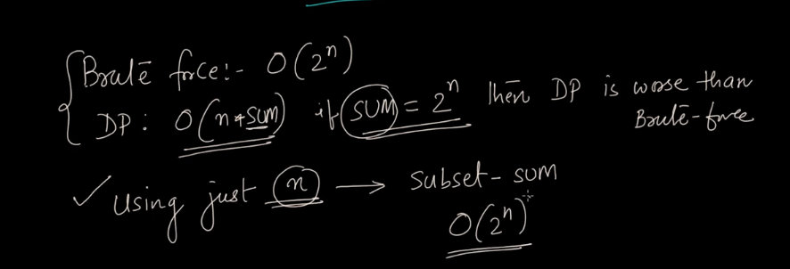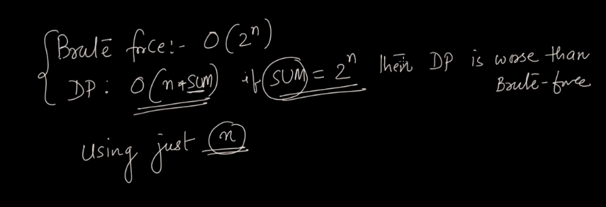

|  |
| --- |
| # A Dynamic Programming solution for subset  # sum problem Returns true if there is a subset of  # set[] with sun equal to given sum    # Returns true if there is a subset of set[]  # with sun equal to given sum  def isSubsetSum(set, n, sum):        # The value of subset[i][j] will be      # true if there is a      # subset of set[0..j-1] with sum equal to i      subset =([[False for i in range(sum + 1)]              for i in range(n + 1)])        # If sum is 0, then answer is true      for i in range(n + 1):          subset[i][0] = True        # If sum is not 0 and set is empty,      # then answer is false      for i in range(1, sum + 1):           subset[0][i]= False        # Fill the subset table in botton up manner      for i in range(1, n + 1):          for j in range(1, sum + 1):              if j<set[i-1]:                  subset[i][j] = subset[i-1][j]              if j>= set[i-1]:                  subset[i][j] = (subset[i-1][j] or                                  subset[i - 1][j-set[i-1]])        # uncomment this code to print table      # for i in range(n + 1):      # for j in range(sum + 1):      # print (subset[i][j], end =" ")      # print()      return subset[n][sum]    # Driver code  if __name__=='__main__':      set = [3, 34, 4, 12, 5, 2]      sum = 9      n = len(set)      if (isSubsetSum(set, n, sum) == True):          print("Found a subset with given sum")      else:          print("No subset with given sum")    # This code is contributed by  # sahil shelangia. |

**Output**

Found a subset with given sum

**Complexity Analysis:**

* **Time Complexity:** O(sum*n), where sum is the ‘target sum’ and ‘n’ is the size of array.
* **Auxiliary Space:** O(sum*n), as the size of 2-D array is sum*n.

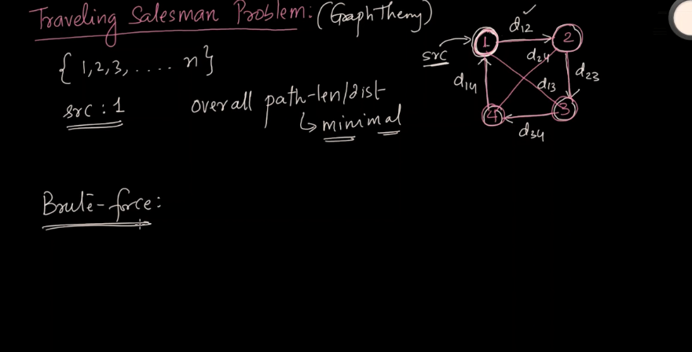

Here we need to touch every city and come back to the source.

